- Startup Name
This start-up I selected is Zepto, which is fast commerce company that was founded in 2021. Sends groceries, personal-care products and everyday items via an app. The ability of a quick commerce platform to provide the customers with orders within a timeframe, which is sometimes less than 10 minutes. I selected Zepto as an illustration of how swift delivery can enhance the convenience of consumers, but also the swift growth can drive up costs.
- Founder(s)
Aadit Palicha, Kaivalya Vohra are the founders of Zepto. The company's filing from June 2026 has Palicha as the Managing Director and CEO of strategy and operations. Vohra is a Whole-Time Director of the technology and product strategy space at his company. In an enterprise such as this, both the app and delivery are integral to the business and both are important. The issues with the app installation and delivery process may compromise the customer experience. Hence, it is vital to have both the online and offline aspects of the business that are guided.
- Business Idea
Zepto's concept is simple: It's about making small and urgent purchases easier and faster. They place orders via the app and their products are collected from dark stores. The delivery partners then goes to the customer doorstep with the order. Dark Stores are not retail stores. Dark Stores aren't stores. They aren't anything more than online order only stores. Items are. Sent out not to serve walk-in customers.
Imagine that someone is making breakfast and realizes that he doesn't have any milk. One of the ways they can do that and can use the app is to order milk and it would be there within minutes instead of having to stop and go get milk. The benefit here's to save time and effort. . . However, the speed isn't all that's required. However, if the milk is bad or the wrong kind was delivered, if the price is too high, the convenience is lost. I don't like promises of delivery, if they can't be reliable to me.
- Target Customers
There are three groups of customers that I would identify. The first are those employees who have their basic needs met, but have established routines. Secondly are students purchasing snacks, beverages or small household products. Thirdly, families who have to fill in the gaps between the shoplifts. These groups are not Zepto groups, they are based on the analysis that I did. Customers need will differ from time to time. When a customer calls in for milk it is not always because it is cheap, as much as it is because he or she is in need of the product; he or she may be more concerned with the speed of the delivery, hence the reason. If there is a family that decides to go shopping once a week, they may be more concerned with the total hand cost. In this respect I believe Zepto should focus on finding a customer according to the necessity to shop and from where one can get the product and service he/she has ordered.
- Revenue Model
There are four sources of revenues listed. They are explained below:
Product commissions Fees - that are associated with products on the platform that are sold by merchant partners.
Advertising - Brands will pay to advertise their product and be seen.
Delivery and logistics incomes - Income from delivery and logistics services.
Procurement and distribution Income - generated from purchasing goods and selling them to the wholesaler or retailer.
This is an excerpt from Zepto's June 2026 prospectus. The income received to the commission should not be taken as a total value of the order placed by the customer. What question can I ask to do my analysis is how much is left after serving that order? All of these have to be attended to, including picking, packing, delivery, discount and refunds. Customers may be acquired by a business. Where it is spending more for them than it is earning, it still won't make money.
- Funding Raised
Zepto has raised fund money for round. Selected rounds are represented in Figure 1 and the value is shown for each date. These are round values, NOT an estimate of the value of Zepto now.
Figure 1. The funding rounds and valuations have been selected.
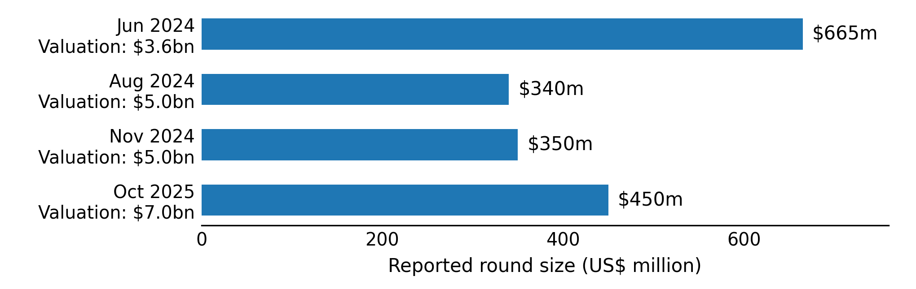
CalPERS, General Catalyst, Goodwater Capital and Lightspeed participated in the October 2025 round. Technology capability to deliver and is growing in size, can be helped by funding. However a valuation is not money in the bank. Also, money provided to the owners in a second sale does not provide any new money to the company.
The listing was delayed and in a report dated 01 Aug 2026 it was mentioned that a pre-IPO round of about ₹1,000 crore is expected. It is not included in the chart as the report indicated that it was a "planned deal" not a completed deal. [6]

- Main Competitors
The direct competitors of Eternal are Eternal's Blinkit and Swiggy Instamart. Amazon, BigBasket and Flipkart are also in this market. There will be small grocery stores available, particularly if they wish to have their groceries delivered or if a service that they know is there.
I would shop around these channels with the same delivery address and same time and using shopping basket. Final bill – if there are items available, how reliable the delivery. Being able to see how the refund process works would be more beneficial than merely seeing big discounts. This is a comparison and not a price enquiry. It also highlights some of the reasons why despite being a good app, it could be removed.

- Two Challenges
Challenge 1: The cost and losses of going through. FY2025–26 sales were ₹22,624 crore but the net loss was about ₹5,905 crore. Finances are outlined on Figure 2. Increased sales is not a reason that a company can't be profitable. The number of orders and profits achieved would be compared to the rent and delivery cost of each shop and the labour of each shop would be compared to the labour of the shops. The location of any new store should be based on the notion that there is enough demand for it. Planning inventory is a very important role as the fresh stock which is not sold may get spoilt.
Challenge 2: To compete and to keep customers. Options that Zetco can choose to take, if they don't get deals, they will have to go back to their services. I would ensure that I located and contacted orders which had new items, and were clearly aware of any updates regarding delivery and were quick to respond to any problems. Additionally, the delivery persons will need to be secured to a degree in the service objectives. While a good experience can lead to a repeat buying, a low price can get a sale.
Figure 2: Revenue Growth and continuing net losses 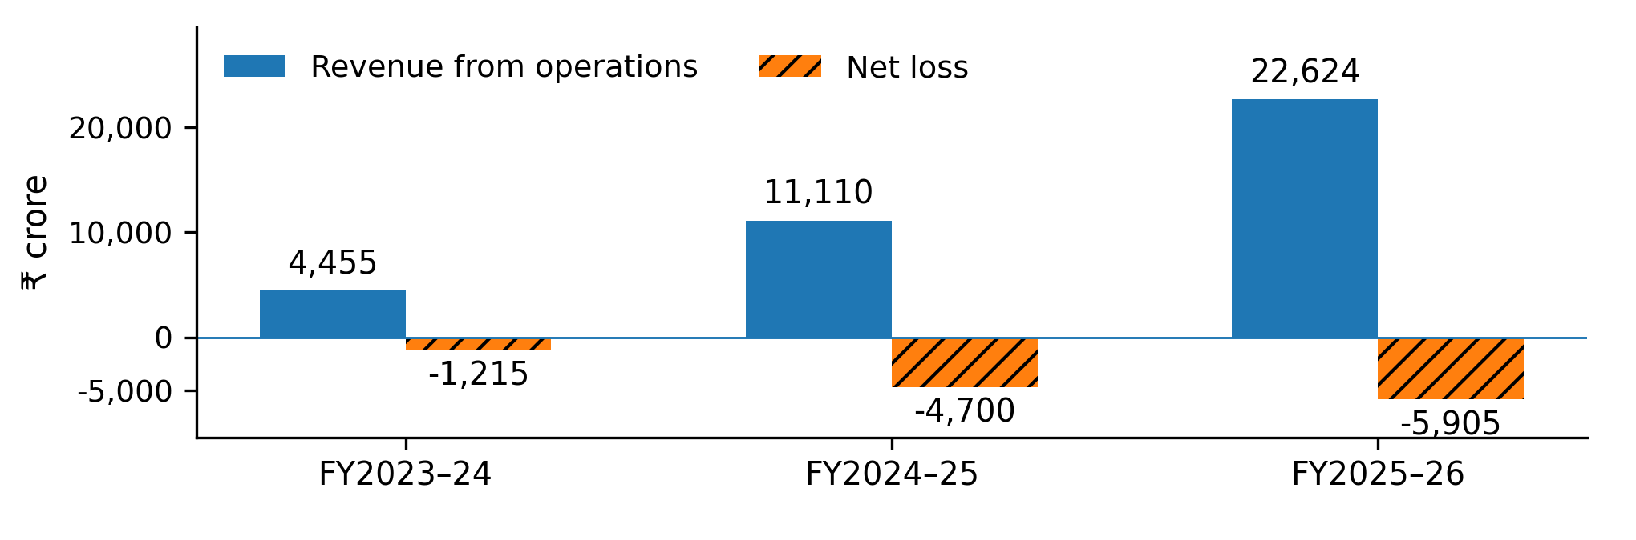
My calculation shows the loss rose by 103.6% for FY 25-26 and revenue by 25.7%. Net loss decreased 42.3 per cent from revenues to 26.1 per cent. This is up from sales. Even though the rupee did not suffer any further losses. The lower the percentage of loss the less profitable that isn't. Do some calculations using the numbers below.

9. Future Growth
First, I would increase repeat orders around existing stores before entering every city. More orders in the area can spread fixed costs across more deliveries provided the team has enough capacity. New locations should be tested for demand, rent and delivery distance before a rollout. Better stock planning is another priority. Frequently bought items should be available while slow‑selling products should be ordered carefully to reduce waste. Advertising is already a revenue source. Paid placements should not make the app difficult to use. To judge progress I would track repeat purchases orders per store stock shortages, refunds and cash used each month. These measures would help show whether growth is making the business stronger.

10. Your View – / Not Successful
I would call Zepto successful in building demand but not yet financially successful. Zepto’s investor website reports over 2.3 million orders a day in January–March 2026. That shows customer use. However, the losses, in Figure 2 mean that long‑term profitability is still unproven. The lesson I take from this case is that solving a customer problem and earning a profit are two tests. Zepto has built a service that people use. The next test is to keep those customers while earning enough to cover Zepto’s costs without depending on fresh investment.

